THE UNIVERSITY OF MELBOURNE
COMP90024 Cluster and Cloud Computing - Assignment 1 – Project Report
By
Naman Brijesh Dwivedi – Student ID- 1763110
Zijun Xing – Student ID -1659029
April 10, 2026
1 Introduction
This document presents the project report for Assignment 1 of COMP90024 Cluster and Cloud Computing at the University of Melbourne. The objective of this assignment is to process two large social media datasets from Mastodon and BlueSky. These datasets are structured in Newline Delimited JSON (NDJSON) format. The primary goal is to identify the languages used in posts and calculate their frequencies, returning the top 10 most frequent languages. These language codes are processed as they appear in the dataset without additional normalization.
2. Application Setup and Innovation
2.1 Spartan Access and Data Setup
The datasets are accessed directly from the SPARTAN file system.
2.2 Application Structure and SLURM Submission
The core application is language_counter_mpi.py, a single Python program that processes both Mastodon and BlueSky datasets. Execution is managed through the SLURM submission script (run_language_counter.slurm) that specifies resource requirements. Jobs are submitted with the sbatch command, specifying the number of nodes and required cores
SLURM submission commands for the three test configurations:
For 1 Node 1 core - sbatch -N 1 -n 1 --cpus-per-task=1 run_language_counter.slurm mastodon-large.ndjson bluesky-large.ndjson
For 1 Node 8 cores - sbatch -N 1 -n 8 --ntasks-per-node=8 --cpus-per-task=1 run_language_counter.slurm mastodon-large.ndjson bluesky-large.ndjson
For 2 Nodes 8 cores- sbatch -N 2 -n 8 --ntasks-per-node=4 --cpus-per-task=1 run_language_counter.slurm mastodon-large.ndjson bluesky-large.ndjson
In these commands, -N specifies the number of nodes, -n specifies the total number of MPI processes, --ntasks-per-node defines how many processes run on each node, and --cpus-per-task=1 assigns one CPU core per MPI process. The SLURM script uses srun -n ${SLURM_NTASKS} python language_counter_mpi.py "$1" "$2" to launch multiple MPI processes, where each process executes the same Python program.
2.3 Parallelisation Approach
This application uses MPI with a data parallel round robin distribution strategy. All processes execute the same code but process different portions of the data. Each process reads the entire file independently but only processes a subset of lines based on its rank where line_num % num_processes == process_rank. This ensures an even work distribution across the processes
Each process maintains a local dictionary mapping language codes to post counts. Posts with multiple languages increment count for each language. After all processes complete their work, MPI gather collects local dictionaries to the master process which then merges them into the final global result.
3. Results & Performance Data
3.1 Language Frequency Analysis:-
During processing the program successfully identified 644,801 Mastodon posts and 641,722 BlueSky posts with no language attributes. The top 10 languages in both datasets are presented below in the form of tables and figures.
Mastodon – Top 10 Languages
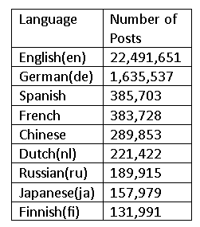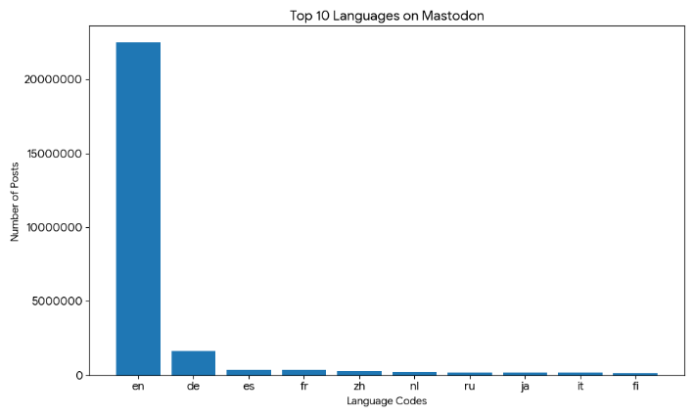
BlueSky – Top 10 Languages
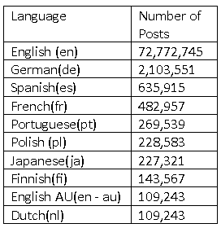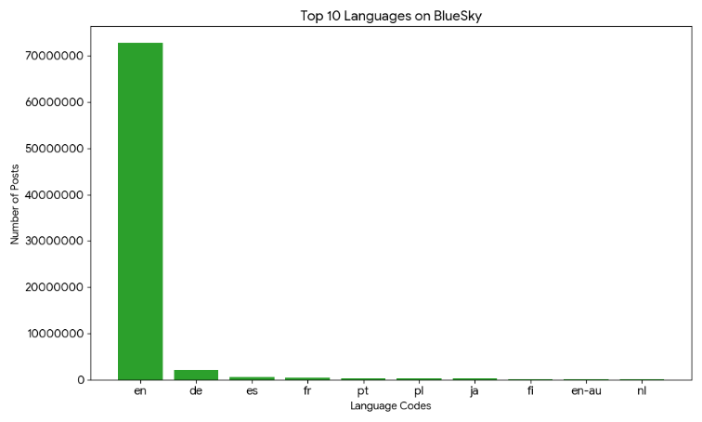

3.2 Execution Time Results
The application was executed once under each of the three hardware configurations, and execution time was measured from job start to completion on SPARTAN:
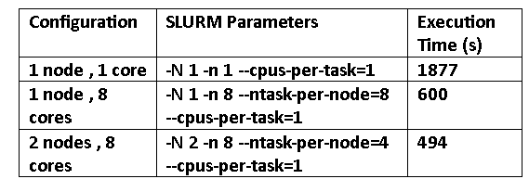
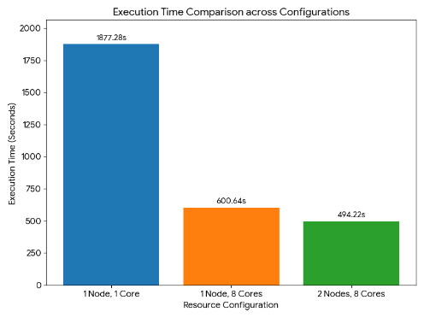
The above Figure shows the execution time of the application under three different configurations: 1 node with 1 core, 1 node with 8 cores, 2 nodes with 8 cores. The datasets were processed using these three distinct computing configurations. The runtime decreases significantly from approximately 1877 seconds in the single core configuration to roughly 600 seconds when using 8 cores on a single node. When the configuration is extended to 2 nodes with 8 cores (4 cores per node), the execution time is further reduced to approximately 494 seconds.
4. Performance Analysis and Amdahl’s Law
4.1- Speedup and Scalability
The speedup from 1 to 8 cores demonstrates that the application parallelises well. Core tasks :- reading JSON lines , parsing data , extracting language attributes and updating counters distribute effectively across processes with good load balancing . Each process handles roughly equal work on its assigned data subset.
However, the speedup is sub-linear as the runtime does not decrease proportionally with the number of cores. A perfect linear speedup would reduce 1877 seconds by a factor of 8 to approximately 235 seconds. Instead, the observed speedup is only about 3.12x. The discrepancy is caused by serial components: MPI initialisation, synchronisation overhead and result aggregation all of which are handled by the master process. Additionally, because every process independently reads the entire input file, I/O work is heavily duplicated.
The transition from 1 to 2 nodes provides minimal benefit. Because the total parallelism remains at 8 cores, further computational speedup is not possible. Furthermore, network communication between nodes introduces inter-process overhead that partially offsets any performance benefits gained from physical separation.
4.2 – Amdahl’s Law Analysis
Amdahl’s Law states the maximum speedup is limited by the fraction of the program that cannot be parallelised. Even if parallel portion runs infinitely fast, the serial components set a ceiling on overall performance improvement.
Our results exemplify this principle. The serial components which include MPI setup & teardown, synchronisation barriers, final result aggregation account for a substantial fraction of the execution time. This becomes particularly evident as the core count increases, making the ratio of serial to parallel work comparatively less favourable.
The round robin distribution strategy while simple and robust contributes to these scalability limits. Having every process independently scan the entire file creates I/O bottlenecks that worsen as more processes are added. A scatter-based approach with file pre-partitioning could reduce I/O overhead though it would add implementation complexity.
5.Conclusion
This project successfully implemented an MPI based parallel application to analyse the language usage in large social media datasets on SPARTAN. The application processes Mastodon and BlueSky NDJSON files to extract language codes and compute post frequencies. In both datasets English dominates both platforms: 22.5 million posts on Mastodon, 77.8 million on BlueSky.
Performance benchmarking demonstrated substantial practical benefits from parallelisation. The execution time decreased from 1877 seconds for 1 core 1 node to 600 seconds for 8 cores on 1 node and finally to 494 seconds for 8 cores across 2 nodes. The sub-linear speedup reflects Amdahl’s Law and highlights practical limits imposed by serial overhead and I/O bottlenecks.
The implementation successfully demonstrates core HPC concepts: distributed data processing, MPI communication patterns and performance analysis on real hardware. The round robin distribution strategy prioritises clarity and correctness over peak performance by making it suitable for educational purposes while illustrating the practical constraints of parallel computing

6. Use of LLM
Large Language Models were used as a supporting tool during the assignment primarily to assist with understanding concepts and improving the clarity of the implementation and report. During development ChatGPT was utilised to clarify how MPI works , including concepts such as rank, size, barriers and result aggregation. It was also used to review whether the overall program structure and SLURM configuration were reasonable and to help identify possible issues during debugging .
For the implementation suggested ideas from the LLM were not used directly without verification . Instead, they were adapted and tested on the small and medium datasets before being applied to the final program. The final solution including the round robin data distribution and the use of MPI gather for result aggregation was chosen based on correctness and consistency with the assignment requirements.
Overall, the LLM was treated as a support tool rather than a replacement for active development . The final implementation , testing and analysis were completed entirely independently.

